**CSCE 5430 SECTION 009 – SOFTWARE ENGINEERING**

**DELIVERABLE -3**

**PROJECT NAME : ANDROID WOMEN SAFETY APP**

**TEAM NAME : SOFTWAREENGINEERING_PROJECT**

**TEAM MEMBERS:**

Krishna Sai Ujwal Kambhpati

Vineesha Sangepu

Sharan kumar Pallapu

Praveen Reddy

Jayakanth Madineni

Vineela Pamarthi

Sai Tai Prathyusha

**Softwareengineering_project Project**

**Deliverable 3 -Project Phase 1**

**Report Requirements for Phase1**:

The functional requirements for phase 1 are as mentioned in deliverable 2.

The functional requirements are as Follows.

* The Requirements for this phase includes the Login page, Registering for the new account, sign-in page and add emergency contact information.
* Login Page:

This page allows the user to Login into the application. The user logs in with the individual phone number and password details. The login page consists of two functionalities sign-in and create account.

Sign in:

* To Sign in into the account, user has to enter the details of phone number and the password of the account.

Create Account:

* When clicked on the Create Account, it directs to the new page named New account.
* To create a new account the following information has to be entered:
* Phone No, First Name, Last Name, Age, Gender ( consists of the dropdown menu), E-mail, City, Address, Password, and confirm password.
* After entering all these details, a new account is created for the user and the account will be accessible to user by entering the appropriate details in the Sign in page.
* Add Contact
* In this phase, we add the functionality of adding the emergency contact.
* Through this feature, the user can add the person’s contact details to whom he/she wants to send the notification of danger or enable to let the person track the location of the user .
* We need to enter the name and phone number of the contact person and it will be displayed in the contacts section of the application.
* Dashboard
* The Dashboard page is displayed once the user logs into the account.
* In this page, we can see the menu and features of the application. For this phase, we add the features like displaying the contacts, fake calls, secure me, feedback and logout options.
* Profile: It displays the user details and user login information.
* Contacts: This displays the contact details of the emergency contacts that are added to the profile by the user.
* Fake calls: This feature helps the user to make a fake call to escape from a scenario.
* Secure me: This feature allows the user to send the notification to the nearby contacts who have installed this application and are users of the application.

The non-functional requirements are as follows:

* Allows numerous users to connect at once.
* "View only" and "full control" modes of operation.
* Windowed, full-screen, and scaled display options.
* Operates in the background as a service on Windows NT computers.
* Supports DHCP and can traverse firewalls.
* Allows for expansive color palettes and pixel densities.

**Changes made from Deliverable 2:**

* The features that are added to the project after the Deliverable 2 are:
* Fake Call: The user can make a fake call with a click on the Dashboard with fake call feature. It helps the user to escape from a dangerous situation and help themselves out of the scenario.
* Secure Me: This feature allows the user to send the notification to the nearby contacts who have installed this application and are users of the application. This feature is useful when the emergency contact is not available or there is no response from the person. It can also be used when the user needs help immediately.

**INTERFACES.**

**User Requirements:**

1. When application is opened it shows sign in activity where the user should create an account by clicking on create new account.
2. In the new account creation activity user details like phone number,first name, last name,email,age, gender, password should be entered and click on register.
3. After creation of account user will be redirected to the home page and asks the user to enter the password to navigate to the dashboard.
4. User will be prompted with the options like “profile”,”Fake Call”,”Add contacts”,”View contacts”,”secure me button”.

**Front End Design:**

**Software Technologies Used:**

**Android Studio** Built on JetBrains' IntelliJ IDEA software and created exclusively for the Android development, Android Studio is the official integrated development environment for Google's Android operating system. It will give app developers access to an IDE that is specialized for Android apps.

**Java** The development of games, desktop applications, web applications, mobile applications, and much more all employ Java. Programming with Java is high level, reliable, object-oriented, and secure.

**PHP** A general-purpose programming language designed specifically for web development is PHP. It is a potent tool for creating dynamic and interactive Web sites and a server scripting language. and it is a well-liked, cost-effective substitute for rivals like Microsoft's ASP.

**MySQL** is an open-source relational database management system.

**XML** is a markup language and a file format for storing, transmitting, and reconstructing arbitrary data. It defines a set of rules for encoding documents in a format that is both human-readable and machine-readable.it was designed to store and transport data it  is a simple, very flexible text format

**Hardware requirements:**

Processor Intel i5 and above

RAM 8 GB and above

Hard Disk 100 GB and above

GPU GTX 1080 and above

**UML design for Phase 1.**

* **Class Diagram**

* **Sequence diagram**

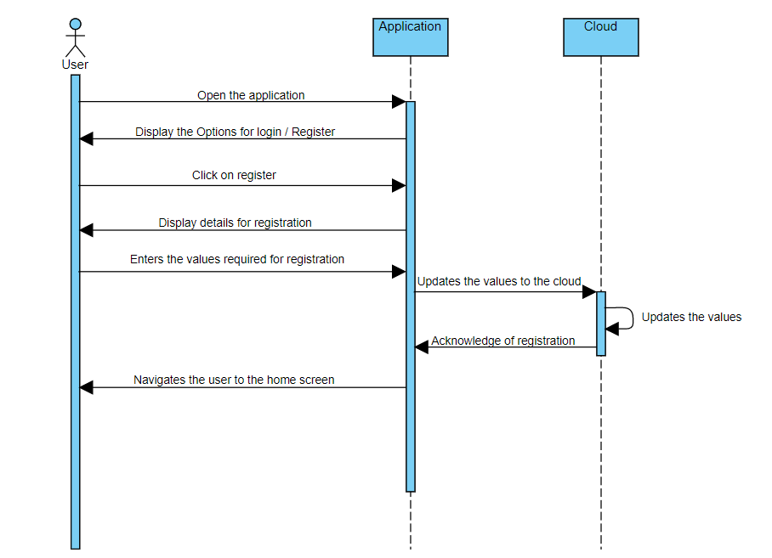

* **Use case diagram**-one normal case and one error case should be included.

SuS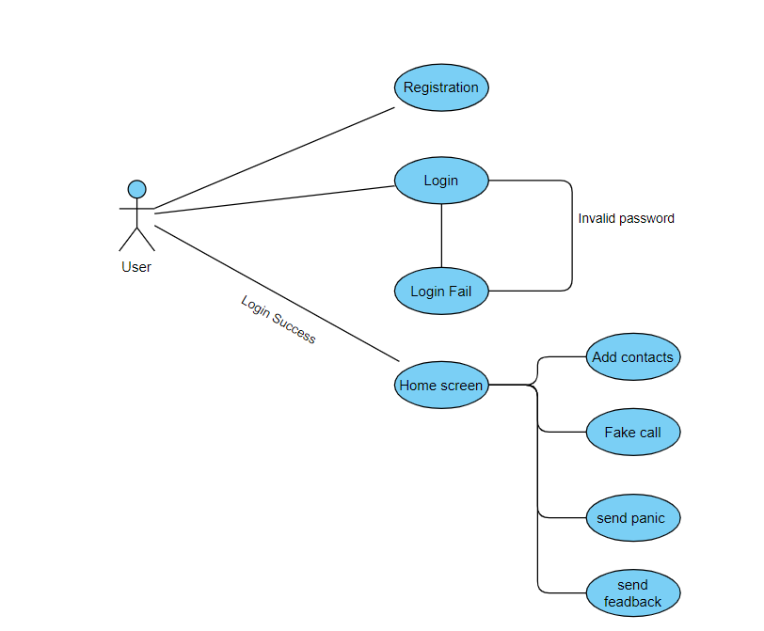

Success case:

Error case:

**Test Cases (unit tests) for phase 1.**

List a set of test cases used for testing the working program including description of tests(example , what functionality that they test, and inputs/outputs for them).

**Test Case 1(Installation of NetBeans)**

Description: Installation of Android Studio

Output: Installation success

Actual Output: Installation success

Result: Success

Description: Installation of Andriod Studio

Output: Critical error

Actual Output: Installation success

Result: Failed

**Test Case 2(Running the Code)**

**Test case A**

Description: Running the Code

Output: Executed

Actual Output: Executed

Result: Success

**Test case: B**

Description: Running the Code

Output: Failed test case1,2..

Actual Output: Executed

Result: Failed

**Test Case 3(User Registration)**

**Test case A:**

Description: User will be entering the details like password, mail id, phone number, first name, last name ,age ,gender,city,address for registration.

Output: Registration Success

Actual Output: Registration Success

Result: Success

**Test Case B**:

 Description: User will be entering the details like password, mail id, invalid phone number, first name, last name ,age ,gender,city,address for registration.

Output: Registration failed (invalid phone number)

Actual Output: Registration Success

Result: Registration failed

**Test Case C:**

Description: User will be entering the details like password, mail id, phone number, first name, last name ,age ,gender,city, invalid address zip code for registration.

Output: Registration failed (invalid zipcode for address)

Actual Output: Registration Success

Result: Registration failed

**Test Case D:**

Description:    User will be entering the details like Insufficient password requirements, mail id, phone number, first name, last name ,age ,gender,city,address for registration.

            Output:            Registration failed (invalid password requirement)

            Actual Output: Registration Success

            Result:             Registration failed

**Test Case E:**

Description:  User will be entering the details like password, invalid mail id, phone number, first name, last name ,age ,gender,city, invalid address zip code for registration.

Output: Registration failed (invalid mail id)

Actual Output: Registration Success

Result: Registration failed

**Test Case 4(User Login)**

**Test Case A:**

Description: User will be entering the password to login to the application.

Output: Login Success

Actual Output: Login Success

Result: Success

**Test Case B**:

 Description:  User will be entering the details like password and invalid user name.

Output: login failed (invalid user name)

Actual Output: login failed

Result: login failed

**Test Case C**:

 Description:  User will be entering the details like invalid password and valid user name.

Output: login failed (invalid password)

Actual Output: login failed

Result: login failed

**Test Case D**:

 Description:  User will be entering the details like invalid password, invalid user name.

Output: login failed (invalid password and invalid user name)

Actual Output: login failed

Result: login failed

**Test Case 5(Fake call)**

Description: User will getting a fake incoming call

Output: Mobile incoming call

Actual Output: Mobile incoming call

Result: Success

**Report User Manual**

A user manual describes how to install/use the application. This helps the end users of the software. Here are the steps needed to be followed to use the application.

1. First, we need to install the software in our mobile. Since we are not launching this app into any app store for now, we can directly install this app as a (.apk file).

This is the welcome page after the installation of the application is done.

1. After the installation is done the next step is the creating an account in the app by entering all the required details.

After entering all the required details, we need to choose a password and submit the user creation form and make sure that we keep the note of the password so that we can login next time without any hustles. Now the user account is created and is ready for use.

1. Once the account is created the next step is to add emergency contact details. You can add the emergency contact details like shown below. We suggest you add these details accurately and double check them.

1. Its always better to add an alternate emergency contact details because in case of emergency if one contact doesn’t respond we always have the feasibility to send the alerts to a second person.

1. After adding emergency contact details, the app is almost ready to use. Once we fill all the details, we can see a dashboard displaying all the features and there is one clickable hyperlink for each feature.

There are 6 features available in the app as of now.

1. CONTACTS: To add emergency contacts. We can always view and edit emergency contact details.
2. View Contacts: To view the list of emergency contacts.
3. Fake Call: This action allows user to make a fake call.
4. Securable: This actions allows to send alert to nearby users
5. Feedback: Users have the option to send feedback using this feature. Whenever they find a bug, they can report using this feature.
6. Logout: We can logout or quit from this app using this feature.

**Report Compilation instructions**

Clear instructions how to compile/run both program ans your test cases

* We have to install JDK with respect to the OS platform.
* Android studio installation is required.
* Then, Open the Android Studio application.
* Select the file menu - select open – and then select path of the project path(Women Safety App) and then click on OK.
* Connect your mobile to the laptop using the USB cable.
* Select the device from the drop down menu on the toolbar
* And then click on the run app button.

**Report Peer Review Feedback**

From the previous discussions that we have had with our peers (group 11 team) and also our own team members, the following are the suggestions that we have accepted and implemented in our application.

* The team has suggested to avoid advertising in the application that can slow down the process of user connecting to the emergency contact. We have accepted this suggestion to reduce the chances of distraction in the application.
* The another suggestion we have implemented is adding more than one emergency contacts. Initially, we have thought of implementing adding only one emergency contact, the change we have made now is enabling user to add more contacts as they wish.

**Report Reflection:**

* As of Phase1, we have accomplished adding login page, New user Registration page, Adding emergency contact information, Fake call feature to help user escape from dangerous situations, Secure me feature to share notifications to the near by users who have signed up for women safety app and are account holders for immediate help to user.
* The things that can be improved in our project User Interface Design, fonts and colors of the application for that to be user likely. We can also improve in adding more features in the application and we as a team are trying to give our best efforts to make a good user friendly application.

**Member Contribution Table:**

|  |  |  |  |
| --- | --- | --- | --- |
| Member Name | Contribution Description | Overall Contribution | Note |
| Krishna Sai Ujwal Kambhpati | Involved in coding of design of the user interface and user experiences. | 12% |  |
| Vineesha Sangepu | Worked on the report requirements and the core functionalities. Worked on UML diagrams for the documentation and testing the application | 14% |  |
| Praveen Reddy Talupu | Worked about the compilation and run instructions. And Peer Review suggestions. | 12% |  |
| Vineela Pamarthi | Worked on the User Manual document and designing the screens of the android application | 12% |  |
| Jayakanth Madineni | Worked on the Report Reflection and organized the zoom meetings for team discussions | 12% |  |
| Sharan kumar pallapu | Worked on the documentation and code functionalities.  Attended meetings for discussions | 14% |  |
| Sai Tai Prathyusha Garikapati | Worked on the test cases of the project in documentation and involved in testing the requirements | 12% |  |